SEMINAR ARTICLE TEMPLATES
ARTICLE TITLE (14pt, Times New Roman, bold, space 1, spacing after 6pt, 14 words long, Capitalize Each Word)
Author Name (12pt, Times New Roman, regular bold, does not include titles with maximum of 5 writers in one article)
e-mail: youremail@domain.co.id (12pt, Times New Roman, regular, space 1)
Institution/affiliation (12pt Times New Roman, regular)
Abstract
Abstract (11pt, Times New Roman, bold, space 1, spacing before 6pt, after 2pt)
The abstract is written in a maximum of 250 words in Indonesian and English. The abstract must be clear, descriptive and briefly describe the problem under study. The abstract includes the background, objectives, methods, and research results and ends without conclusions. (11pt, Times New Roman, regular)
Keywords: (11pt, Times New Roman, regular)
Keywords or keywords from the abstract contain vital concepts that often appear and are used in article writing. The key concept consists of 1 or 2 words with a total range of 3 to 5 keywords. A comma separates each word or phrase (,).
Preliminary (12pt, Times New Roman, bold, after 2 pt)
Preliminary explains the background of the problems being resolved, issues related to the problems being resolved, and reviews of research done previously by other researchers relevant to the research being carried out. It is best to avoid organising the writing into "sub-headings" in this introductory section.
Templates for this article format were created in Microsoft Word and then saved in RTF (Rich Text Format) format. This template allows writers to quickly and accurately prepare articles according to the rules. (12pt, Times New Roman, regular, spacing 1.5, spacing before 0 pt, after 0 pt.)
Method (12pt, Times New Roman, bold)
The methods section (quantitative, qualitative, combined, research and development) explains how the research was conducted, which includes:
(1) The problem to be studied;
(2) Research objectives;
(3) Data collection techniques;
(4) and data analysis techniques.
For qualitative research such as classroom action research, case studies, phenomenology, etc., it is necessary to include researchers, research subjects, informants, or resource persons who help with methods of collecting research data, research locations, and the validity of the research data.
For quantitative research, it is necessary to mention the time and place of research; the research subjects, namely the samples, need to be described clearly in this section, besides the sampling technique for quantitative research, research procedures, types of data forms, how the data is collected, with instruments.
It is highly recommended to avoid using sub-headings in this section. However, if you can't avoid it, write it in the usual format (capital letters at the beginning of the word and bold or bold).
(12pt, Times New Roman, regular, spacing 1.15, spacing before 0 pt, after 0 pt.)

Results and Discussion (12pt, Times New Roman, bold)
This section is the main part of the research article and is usually the longest part of an article/ journal. The research results presented in this section are the final results of writing articles/journals. Data analysis processes such as statistical calculations and hypothesis testing processes do not need to be presented. Only the results of the analysis and the results of hypothesis testing need to be reported. Tables and graphs can be used to verbally clarify research results' presentation. Tables and charts should be commented on or discussed.
The results section contains detailed sections in the form of sub-topics directly related to the research focus and categories.
The discussion in the article aims to:
- answer problem formulations and research questions;
- show how the findings were obtained;
- interpretation of research findings;
- linking research findings with established knowledge structures; and
- bring up new theories or modifications of existing theories.
In answering the problem formulation and research questions, the research results must be concluded explicitly. The interpretation of the findings is carried out using logic and theories that have been obtained. Findings in the form of realities in the field are integrated/linked with the results of previous research or with the theories that have been obtained. For this purpose, there must be references in the form of indexed journals. In generating new theories, old theories can be confirmed or rejected; some may modify the old theories. (12pt, Times New Roman, regular)
Place table labels on top of the table while image labels are at the bottom. Write specific tables specifically, for example, Table 1, when referring to a table. Examples of writing tables and captions are as follows:
Table 1. Format of Sections, Sub-sections, and Sub-Subsections.
 | Font | Spacing
Section | 11-point Times bold | 1 space
Sub-section | 11-point Times Italic | 1 space
Sub-sub section | 11-point Times Italic | Without spaces, and must end with a period

It is recommended to use the text box feature in MS Word to accommodate images or graphics, because the results tend to be stable to format changes and page shifts rather than inserting images directly.

Picture 1. An example of an image caption
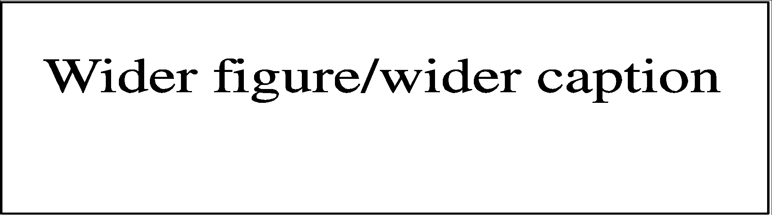
Picture 2. Image / Title is aligned center
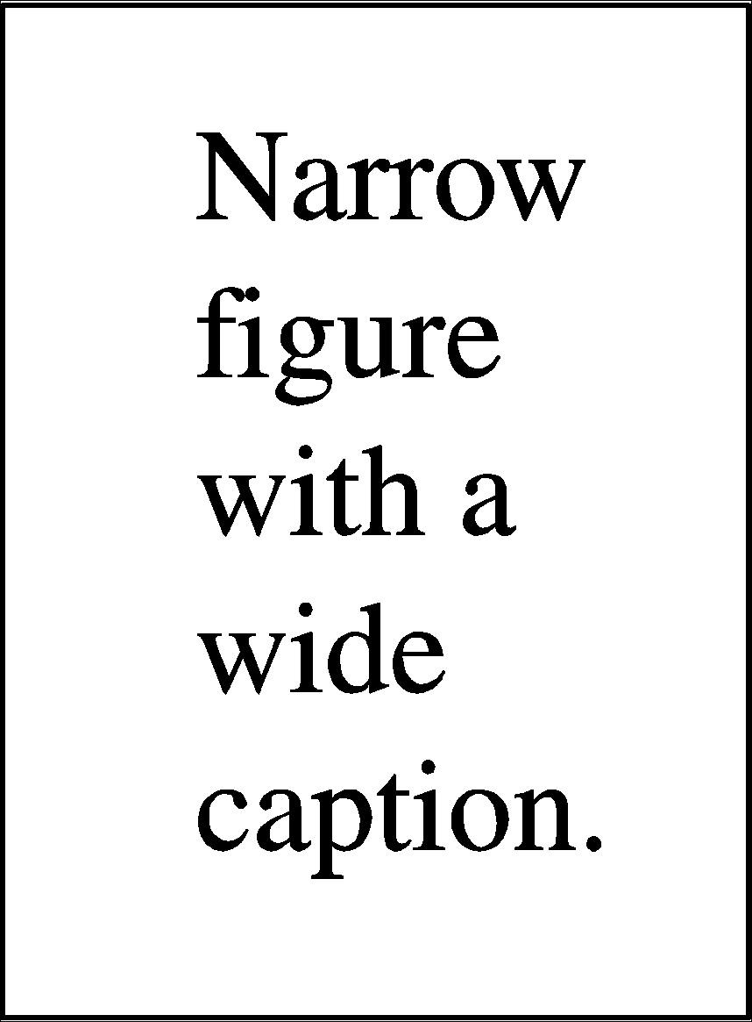
Picture 3. Two pictures are placed side by side to save space. The title is aligned center. |  | Picture 4. Two pictures are placed side by side to save space. The title is aligned center.
Conclusion
The conclusion displays the results of a summary of the research and discussions that refer to the research objectives. Based on these two things, it is developed into new points of thought, which are the essence of the findings of the research results.
(12pt, Space 1.5, Times New Roman, regular)
Bibliography (12pt, Times New Roman, bold)
This section lists books, articles, or other references to articles that have been created. The type of reference recommended in this journal refers to the APA (American Psychological Association) Style 7th Edition. Please use Reference Manager Applications such as Mendeley or Zotero for reference consistency. The bibliography is presented in the following manner, arranged alphabetically and chronologically. For reference sources, 80% of the publications of the last ten years are preferred. References are primary sources in the form of research articles in journals or research reports, including theses, theses, and dissertations (12pt, Times New Roman, regular).

Bibliography
Contains books and sub-books, proceedings, journals, periodic articles, and papers (complete examples):
Green, J. (2018). The Fault in Our Stars. https://www.amazon.com/Fault-Our-Stars-John-Green-ebook/dp/B007Z8ZKS2/
Kluger, J. (2019, July 18). Elon Musk told us why he thinks we can land on the Moon in ‘less than 2 years.’ Time website: https://time.com/5628572/elon-musk-moon-landing/
Patel, V., & Jenkins, R. (2012). Putting Evidence into Practice: The PLoS Medicine Series on Global Mental Health Practice. PLoS Medicine, 9(5), 44. https://doi.org/10.1371/journal.pmed.1001226
Salinger, J. D. (2001). The Catcher in the Rye. Back Bay Books

